Bonnie Bolash, LAc
Acupuncturists4HealthyMN@gmail.com
Published September , 2024

 Acupuncturists For A Healthy Minnesota
Acupuncturist Treatment Room Time Survey

Survey Overview:
A survey of Licensed Acupuncturists was conducting in August of 2024. Emails were sent to 580 email accounts that was previously provided by the Minnesota Board of Medicine in November 2019 of Licensed Acupuncturists.
- Date Conducted: August 2024
- Target Audience: Licensed Acupuncturists
- Number of Emails Sent: 580
- Number of Responses: 35
- Number of Questions: 18
- Response Rate 6.03%

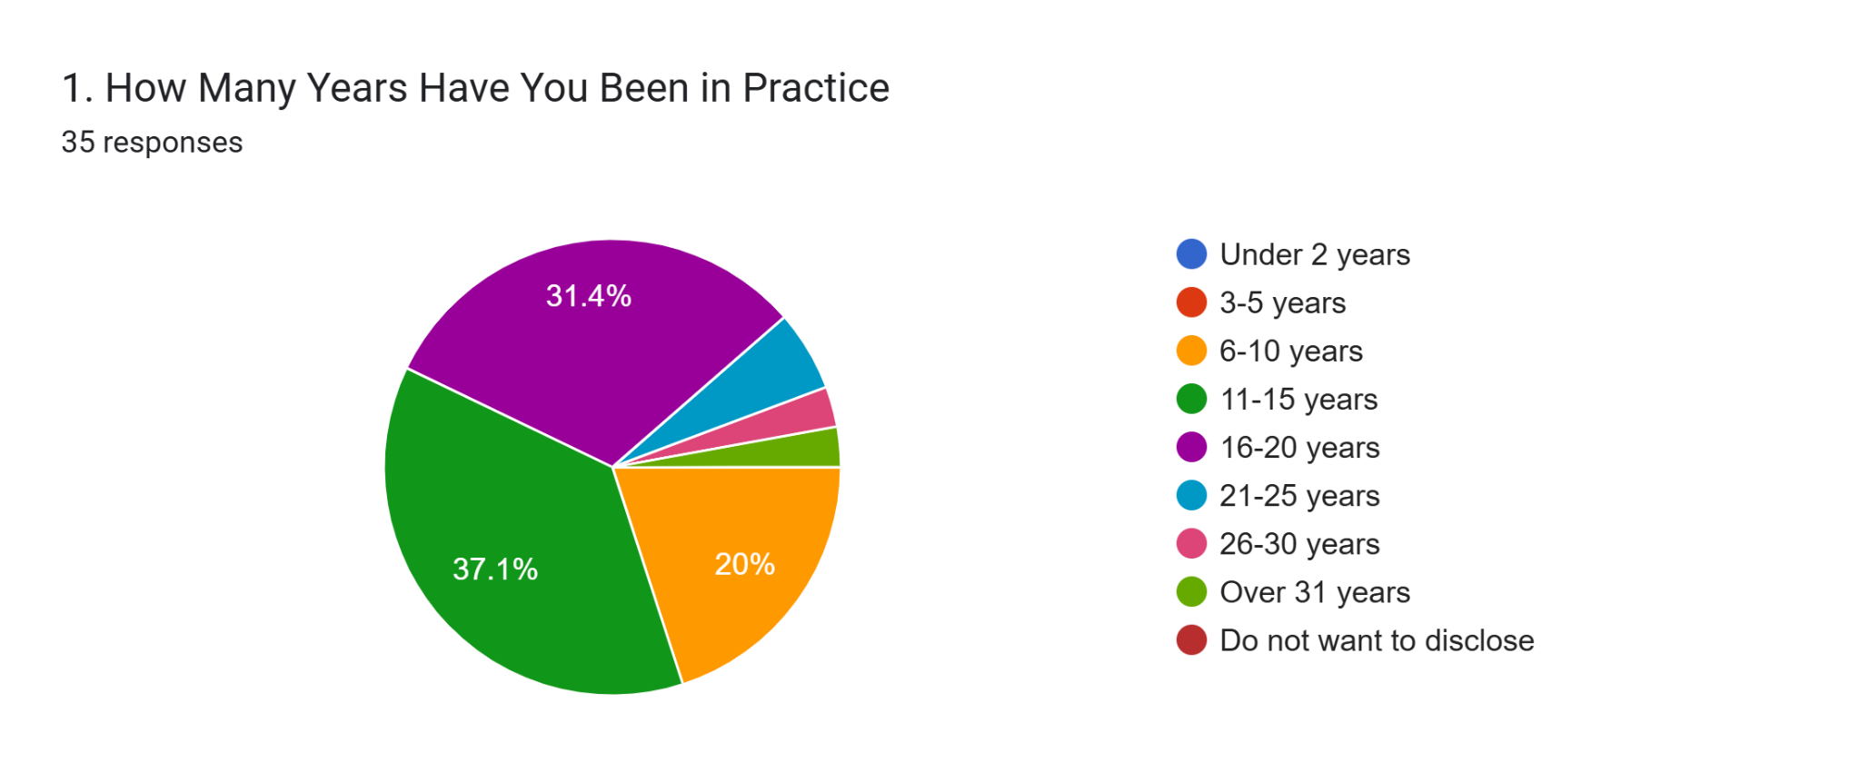
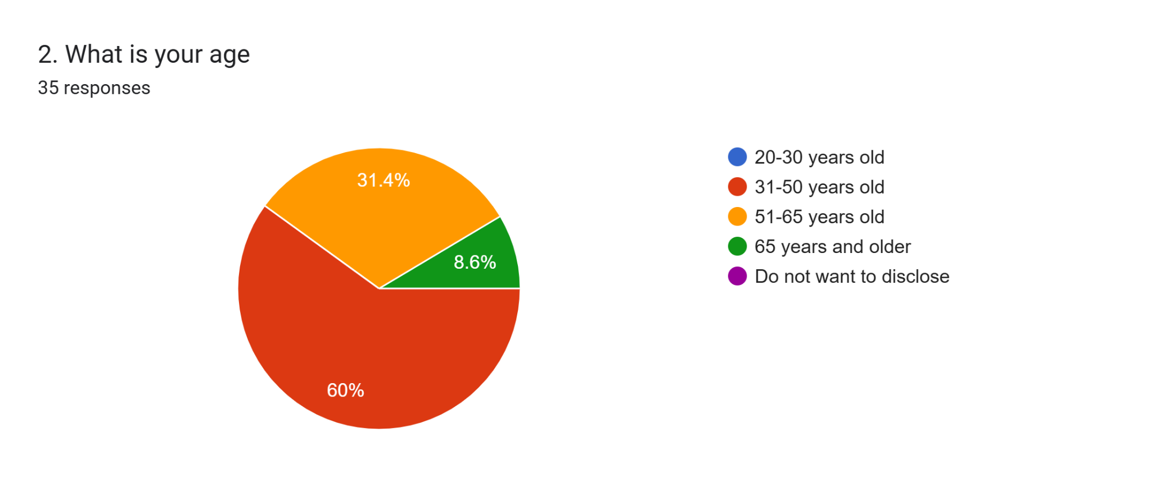
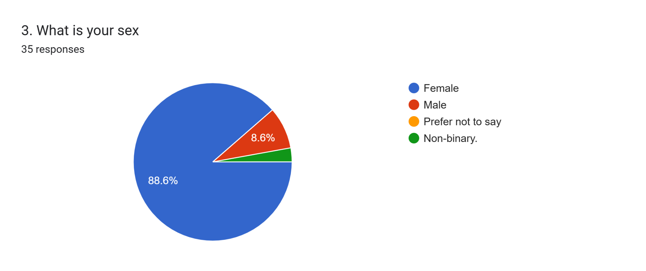

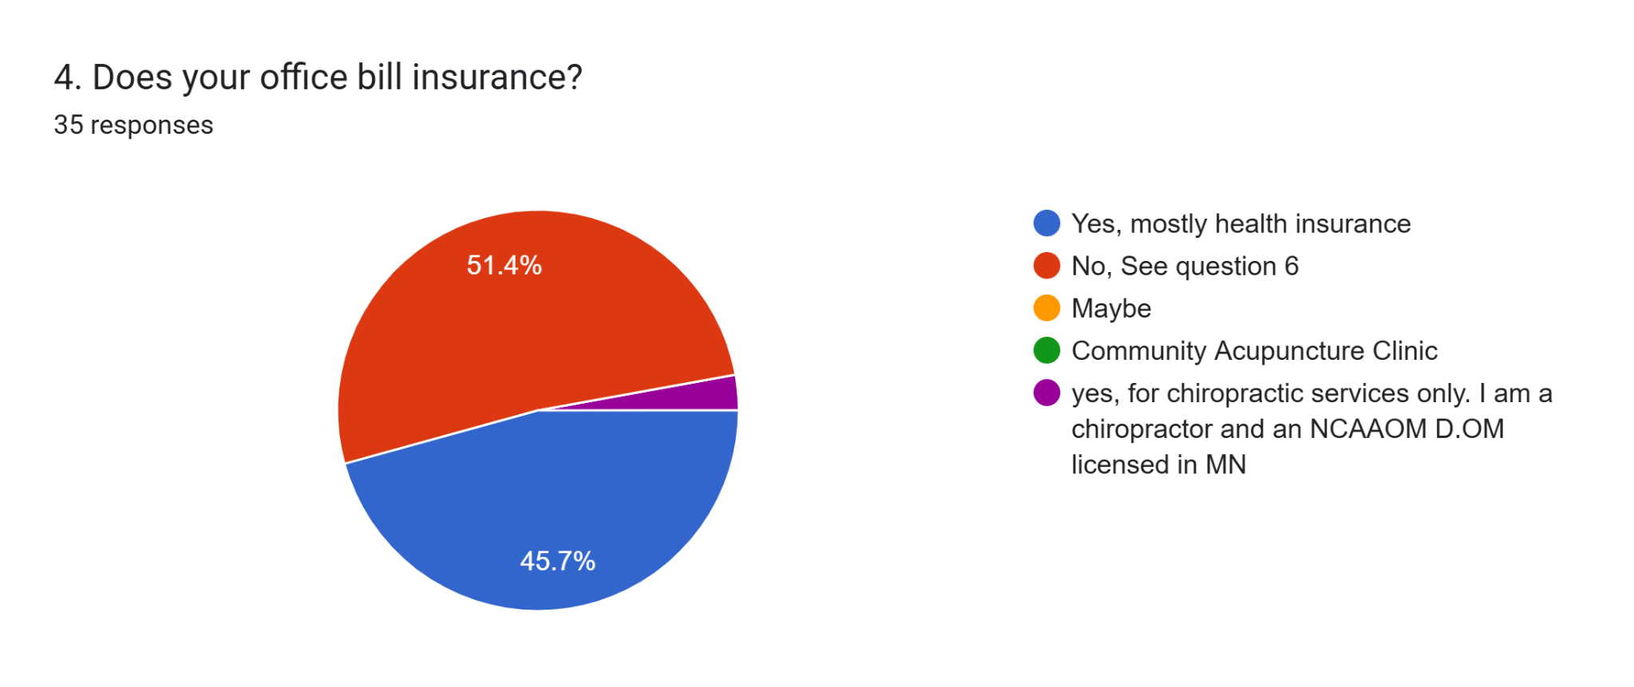
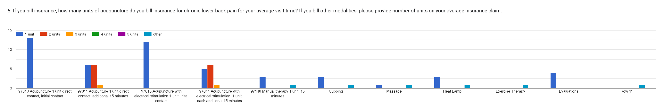

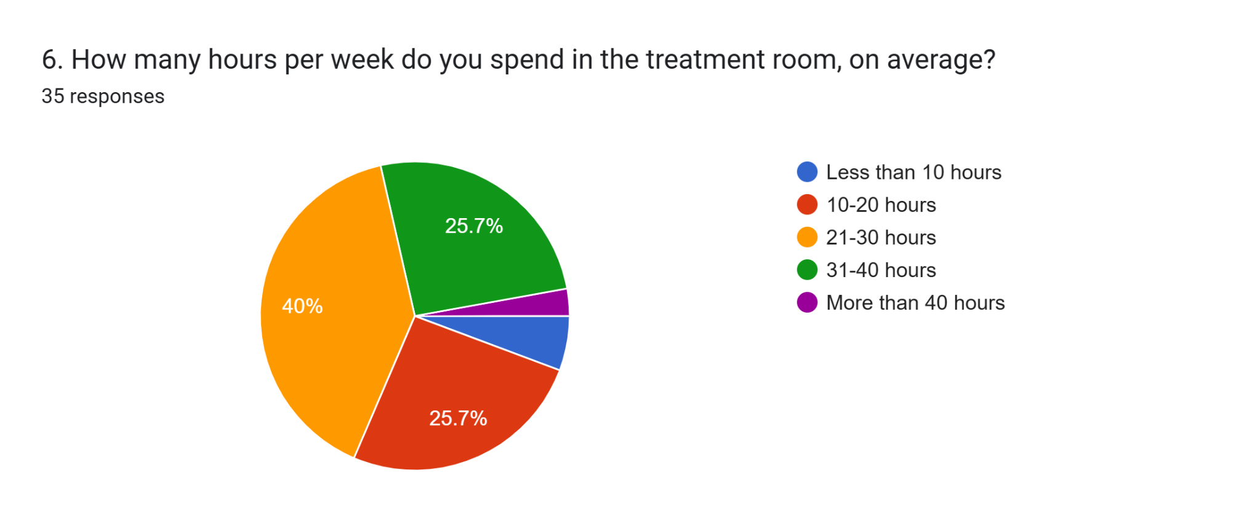
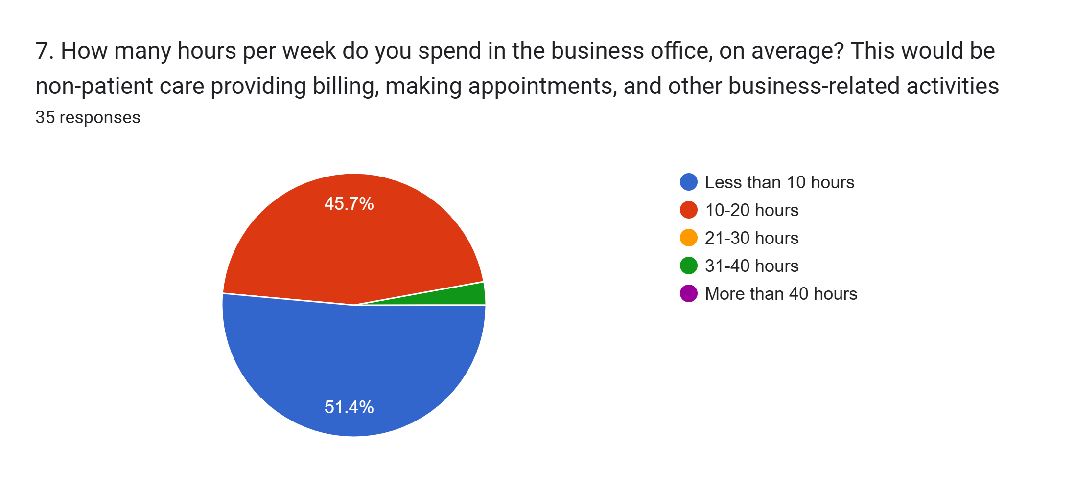
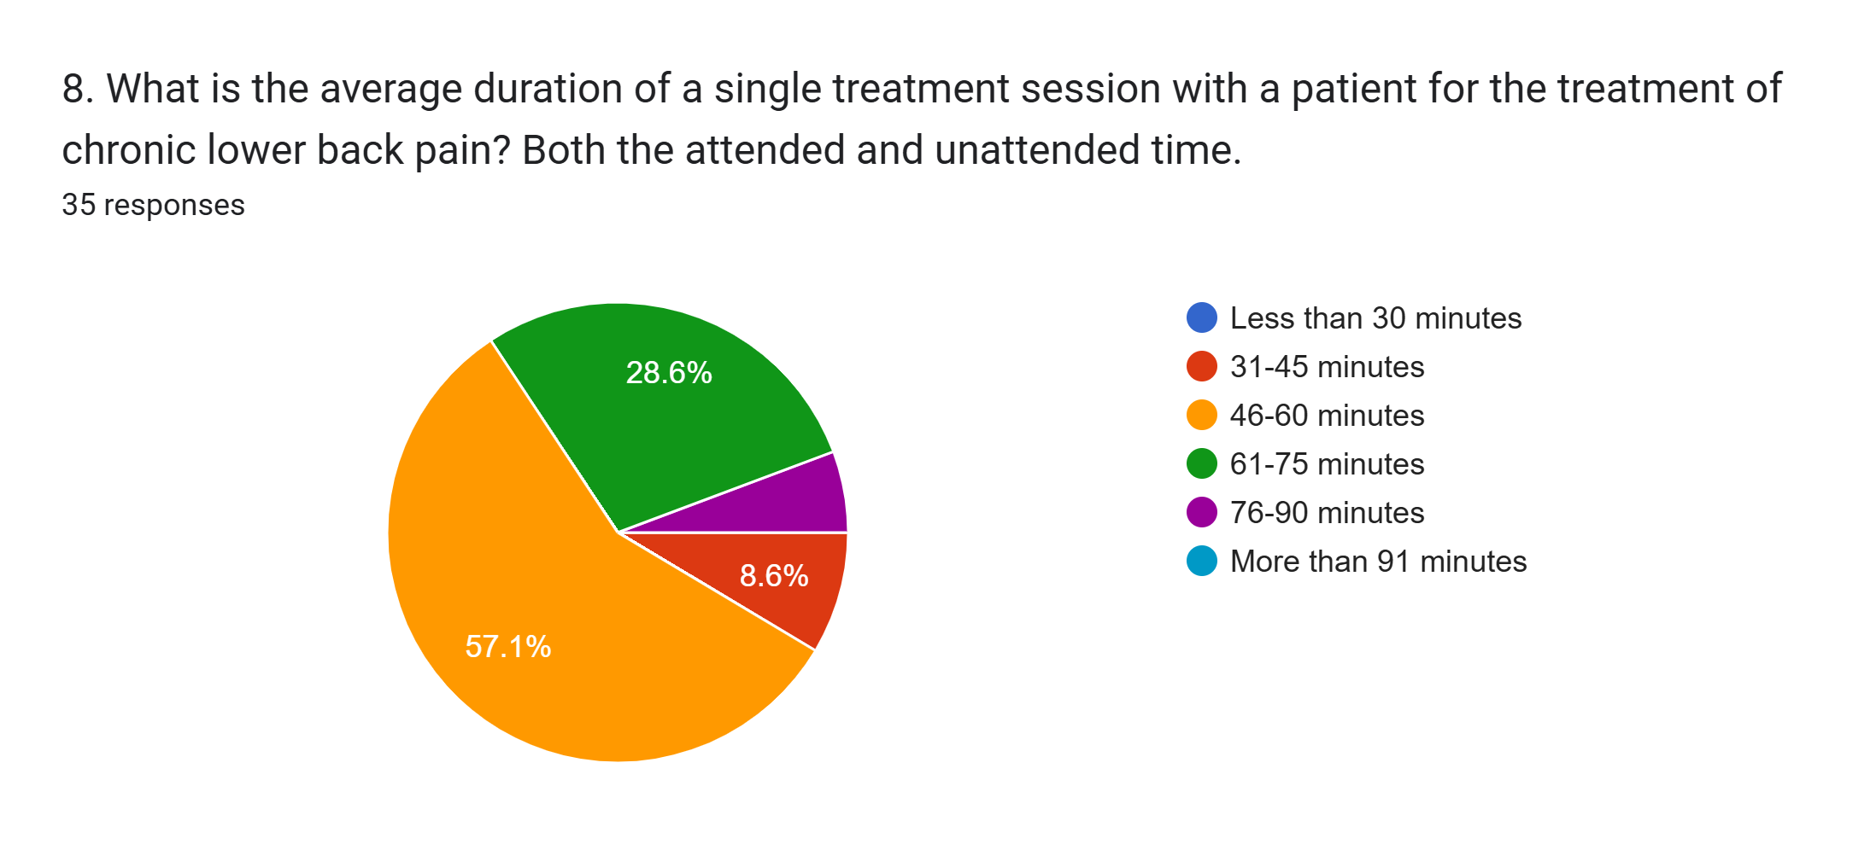
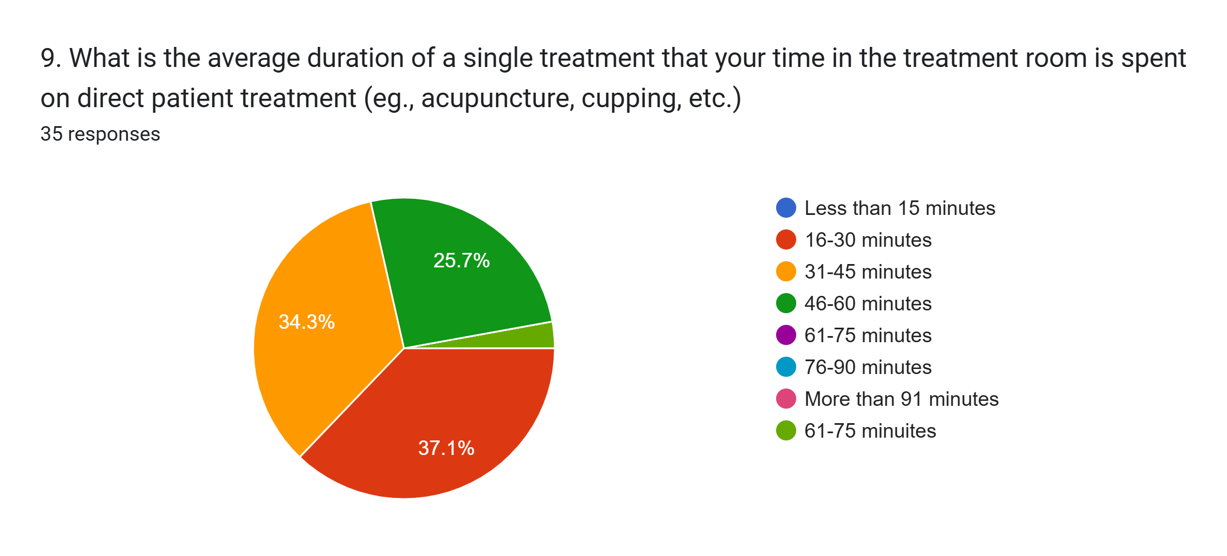

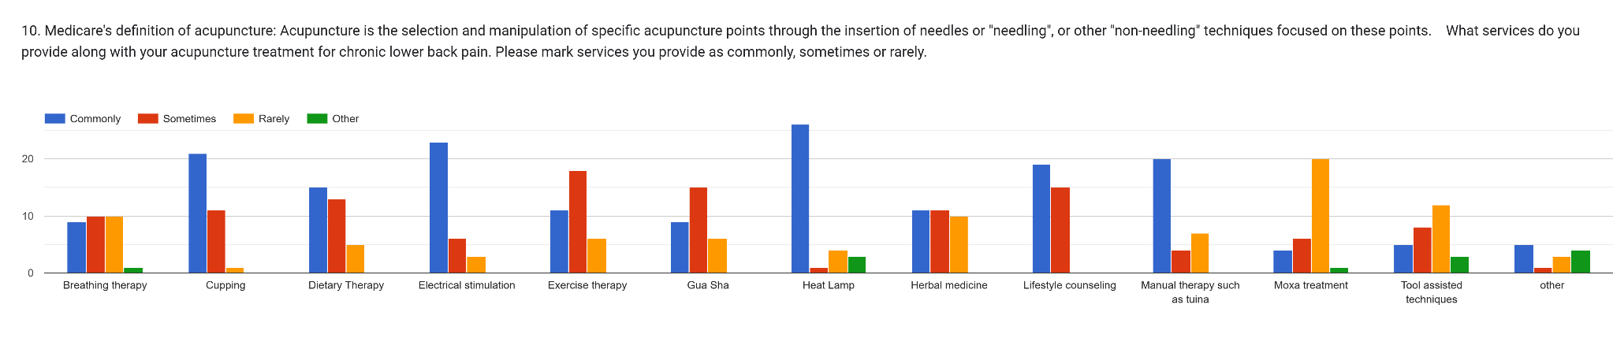

Question 10 regarding non needling techniques used with acupuncture for chronic lower back pain:
Breathing Therapy: Sometimes/rarely
Cupping: Commonly
Dietary Therapy: Commonly
Electrical Stimulation: Commonly
Exercise Therapy: Sometimes
Gua Sha: Sometimes
Heat Lamp: Commonly
Herbal Medicine: Commonly/Sometimes
Lifestyle Counseling: Commonly
Manual Therapy: Commonly
Moxa treatment: Rarely
Tool Assisted: Rarely
Other: Commonly

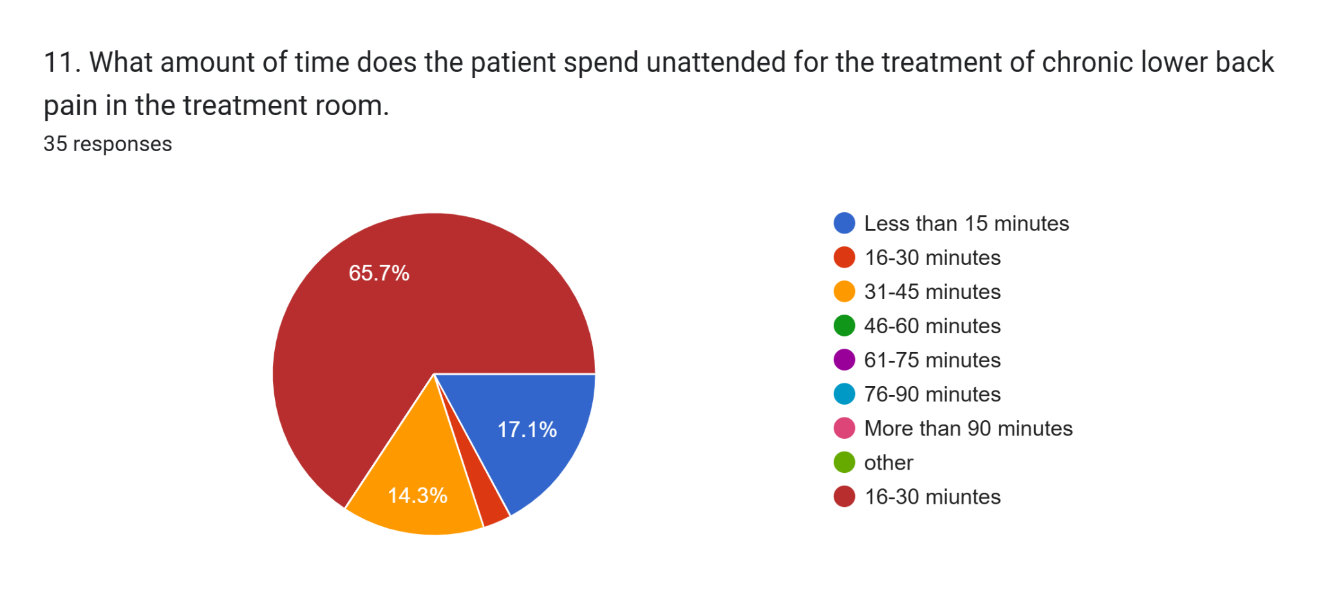
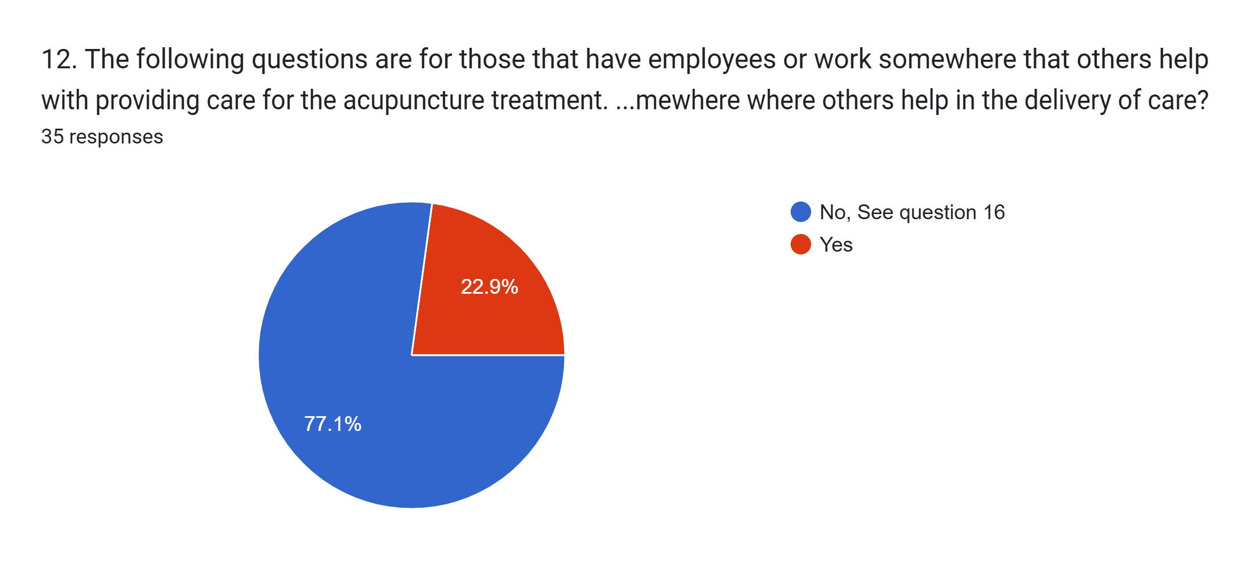
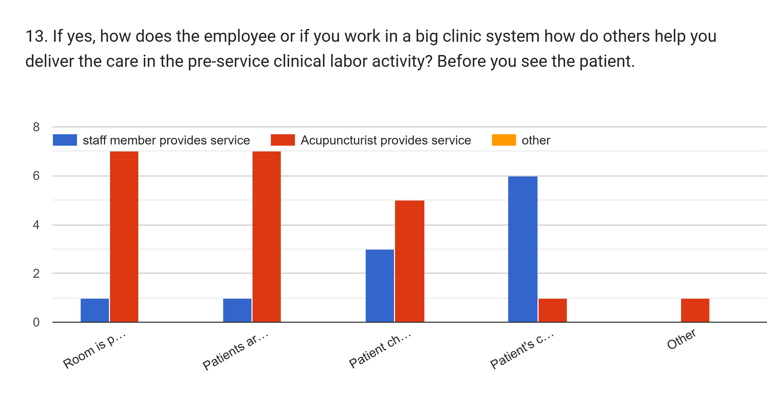
- [Room is prepared and exam table is covered with paper or cloth]
- [Patients are greeted, walked to room and gown is provided or patient is instructed on how to prepare for treatment.]
- [Patient check in, patient education and consent are obtained]
- [Patient's copayment or deductible for insurance are collected]
- Other
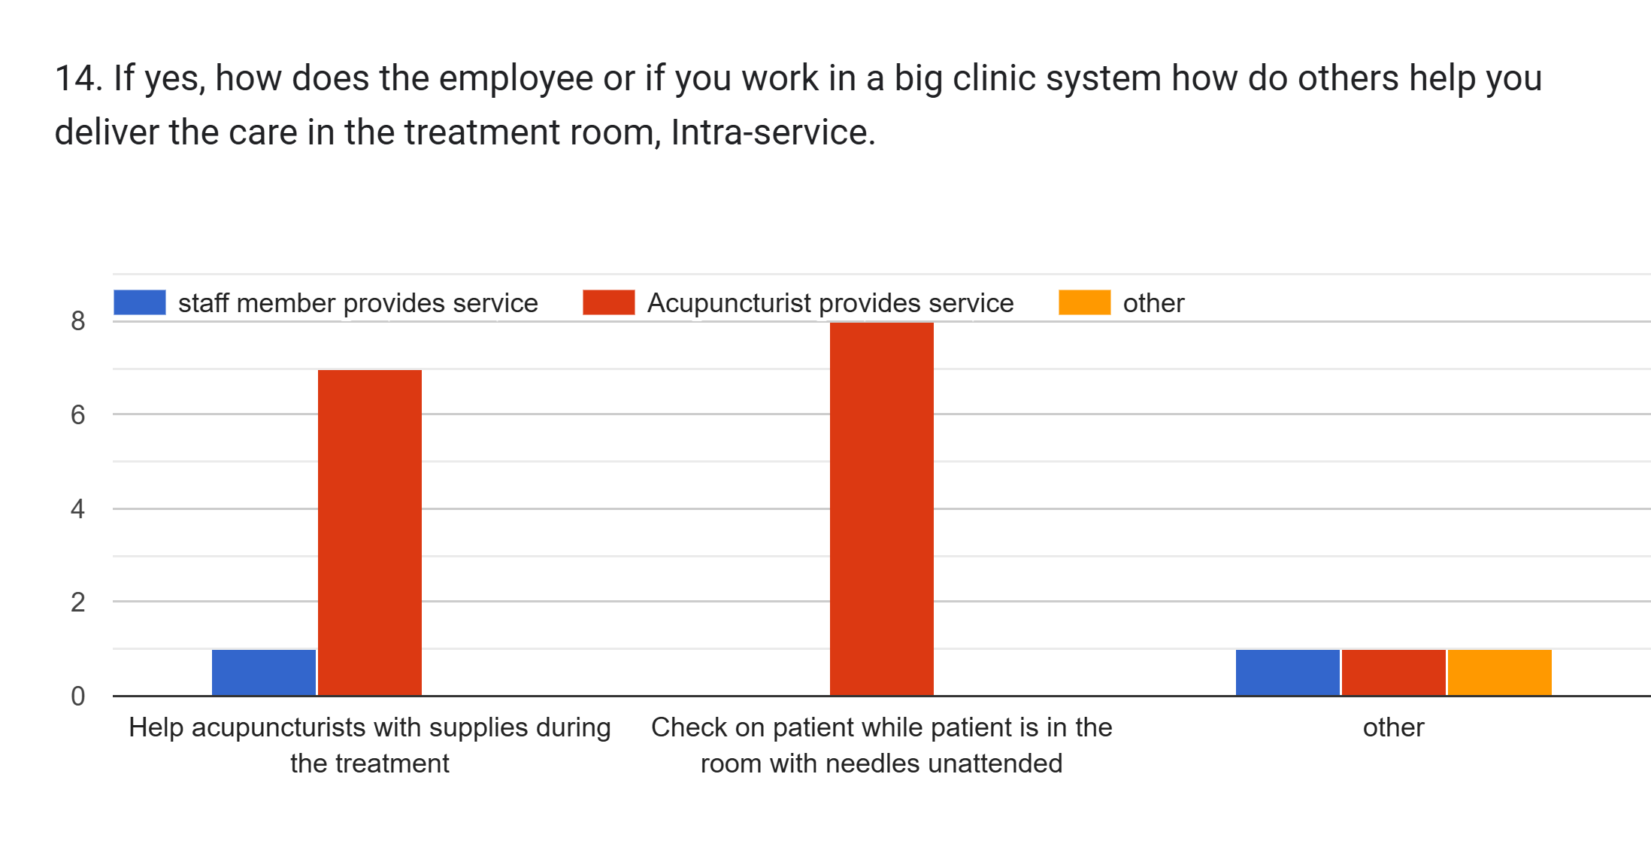

- [Help acupuncturists with supplies during the treatment]
- [Check on patient while patient is in the room with needles unattended]
- Other
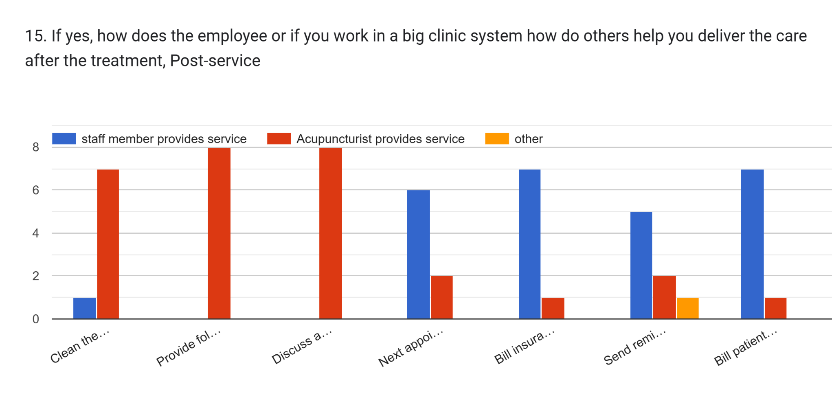

- [Clean the room and disinfect]
- [Provide follow up information to patient]
- [Discuss any adverse reaction at insertion site]
- [Next appointment is set up for patient while checking out]
- [Bill insurance for claims]
- [Send reminders for appointments]
- [Bill patient for services]

Typical Treatment Styles of Licensed Acupuncturists for the treatment of lower back pain
20-40 needles per tx, retention time 20-25 minute, usually one sided
Channel
Chinese
Classical acupuncture; sometimes 2-sided but not often due to time constraints in a hospital clinic system
Depending on the chronicity duration of pain syndrome, this will have an influence of front and back treatment together. My style is TCM (trained at NWHSU).
Dr Tung, Dr Richard Tan, TCM
I incorporate both TCM and Distal/Tung styles.
I often do two sides care in a visit using musculoskeletal techniques.
I provide TCM and a single sided treatment.
Japanese style. Yes if the symptoms warrant it.
Neoclassical Acupuncture and Sa'Am Acupuncture
Occasionally will flip and needle both sides. I use two treatment rooms simultaneously.
Orthopedic Acupuncture including dry needling, yes, can consist of supine, prone and lateral recumbent as needed.
Orthopedic, can be single side or both sided, depending on issue
single room treatment
TCM + some 5E + Shonishin
TCM depending on the symptoms I often treat front and back.
TCM mostly zang fu theory I usually chat 20-30 minutes, do one sided treatment with needles retailed 25-30 minutes then tui na and accessory techniques for 10-15 minutes.
TCM sometimes I do more than single sided treatments
TCM, Japanese, Shonishin, more than single sided
TCM, Kiiko. Sometimes do 4-15 minute units of treatment
TCM, KM, APM, when indicated, i will treat both sides.
TCM, scalp & auricular acupuncture. Some patients are treated both sides. Depends on symptoms.
TCM. Back and front treatments.
TCM. Mostly one sided.
TCM/Japanese
Traditional Chinese Medicine style, Sports Medicine Acupuncture
Traditional Chinese medicine. At times I do both sides. Most commonly 1 side
unknown
unknown
unknown
unknown
unknown
Whole body acupuncture
More than a single sided treatment per visit
Zang Fu. Single sided, usually.

Comparison of Non-Billing and Billing providers Hours in the Treatment Room
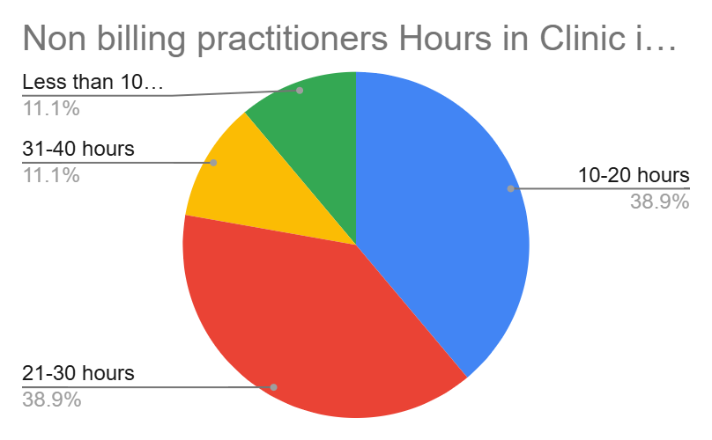
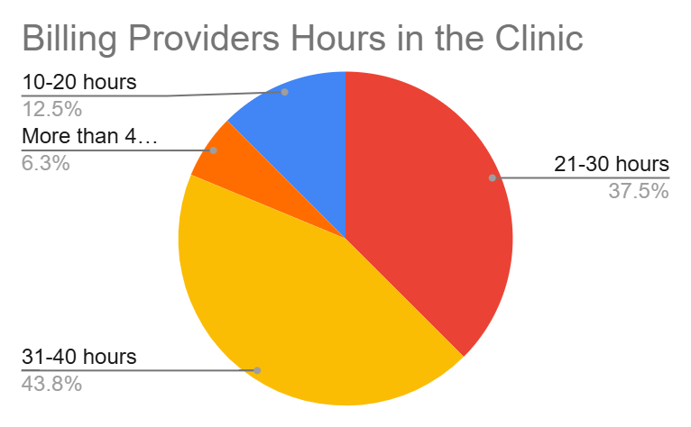

Hours on Business Side Non-Billing and Billing Providers
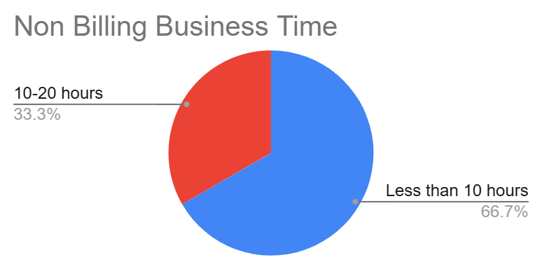
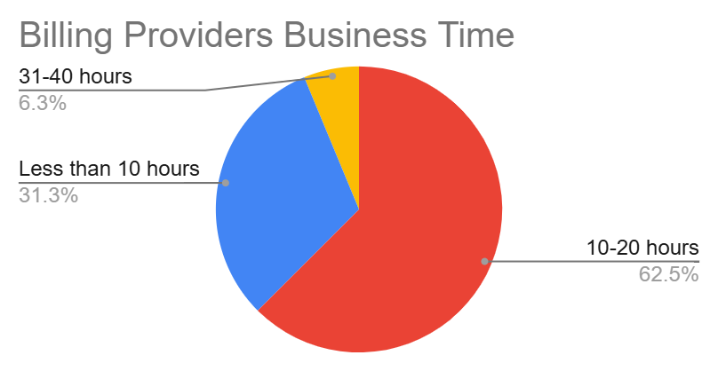
Comparison of Non-Biling and Billing Providers Treatment Times with both attended and unattended.
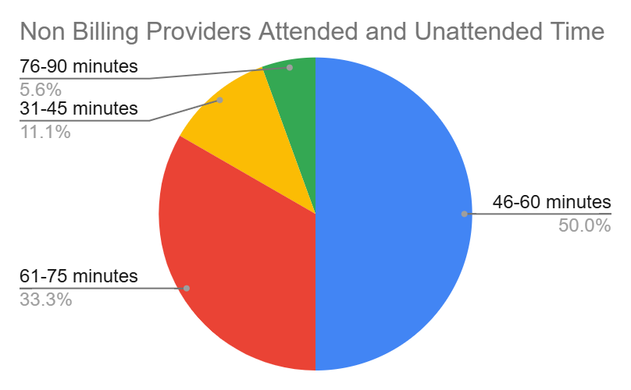

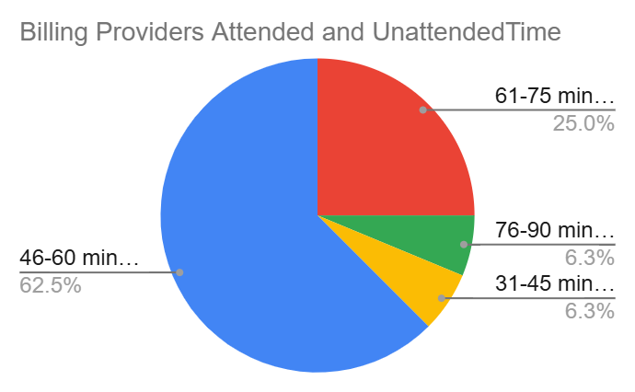
Comparison Non-Billing and Billing Providers Direct Time Per Treatment

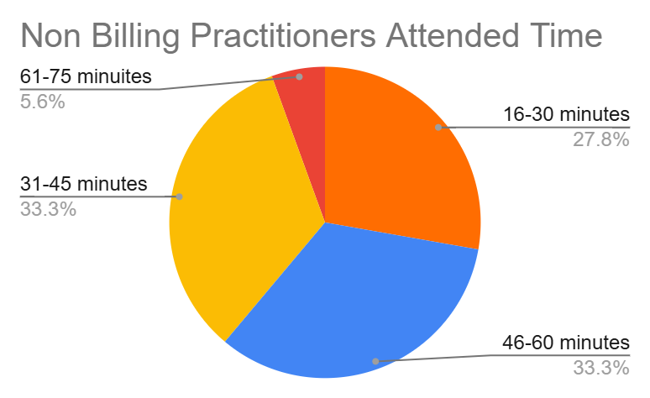
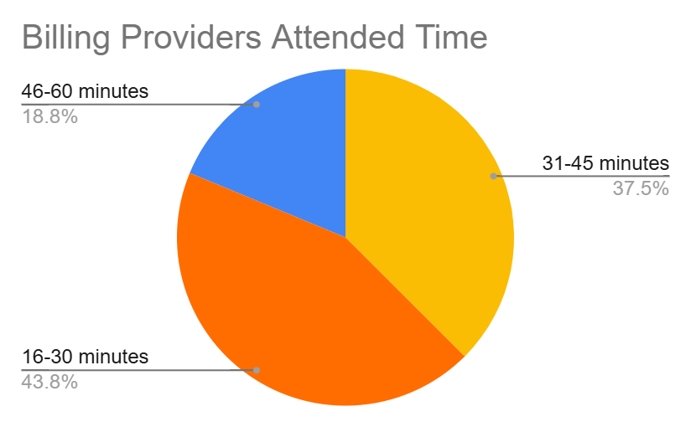
Comparison of Non-Billing and Billing Providers Unattended Time Per Treatment

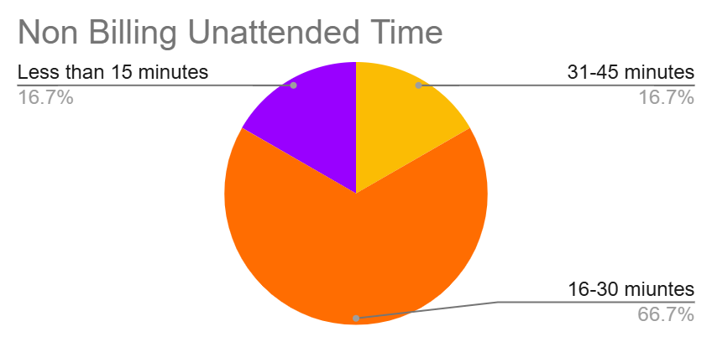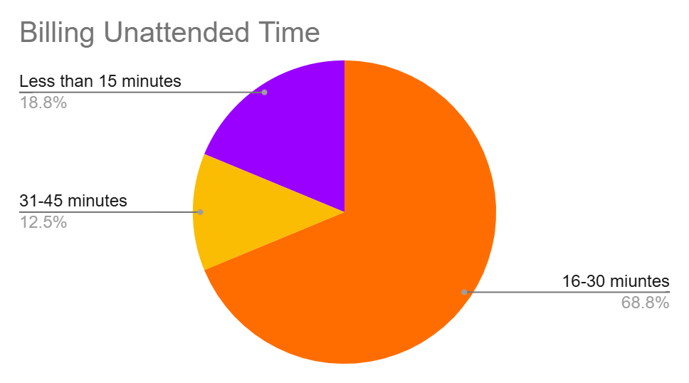

Billing Provider Information
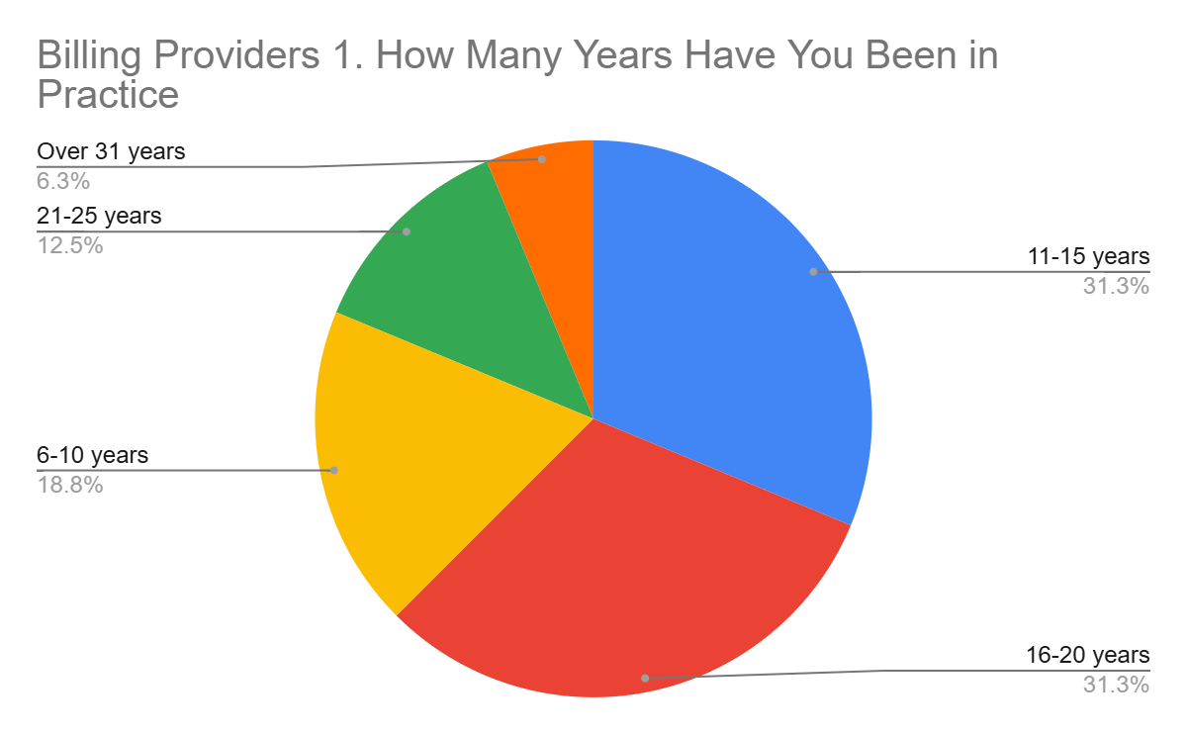

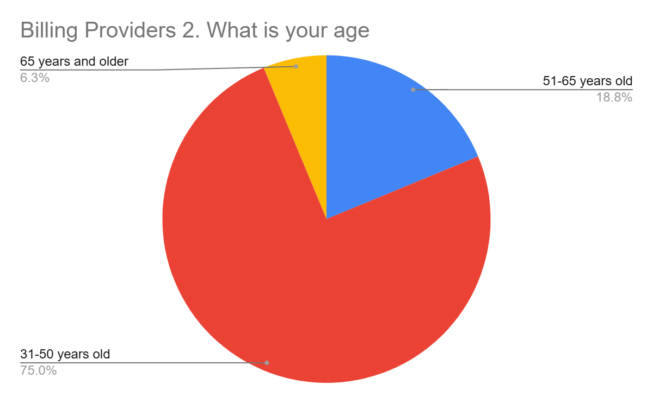
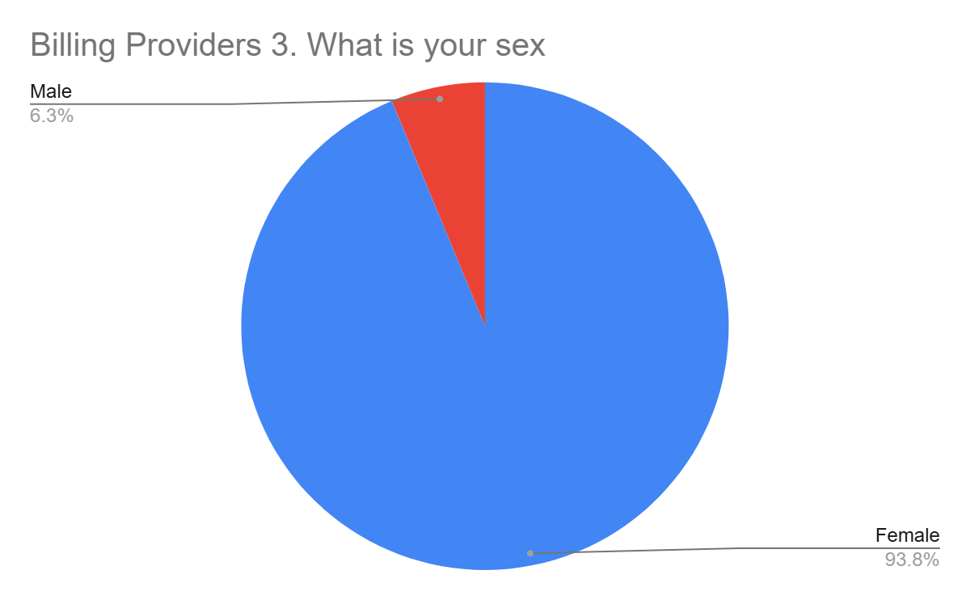
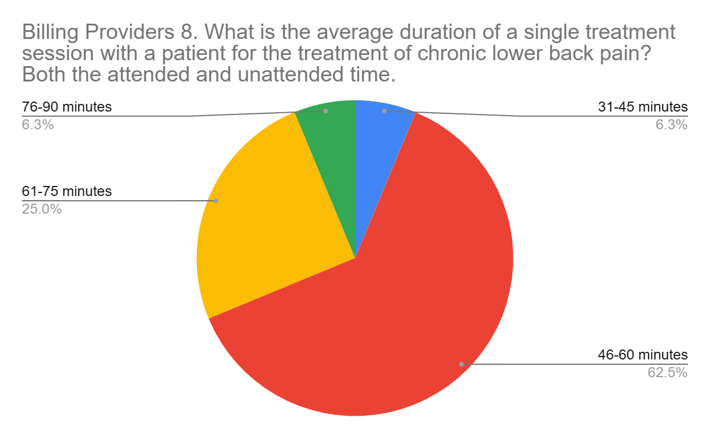

8. What is the average duration of a single treatment session with a patient for the treatment of chronic lower back pain? Both the attended and unattended time. | 9. What is the average duration of a single treatment that your time in the treatment room is spent on direct patient treatment (eg., acupuncture, cupping, etc.) | 11. What amount of time does the patient spend unattended for the treatment of chronic lower back pain in the treatment room. | 5. If you bill insurance, how many units of acupuncture do you bill insurance for chronic lower back pain for your average visit time? If you bill other modalities, please provide number of units on your average insurance claim. [97810 Acupuncture 1-unit direct contact, initial contact] | 5. If you bill insurance, how many units of acupuncture do you bill insurance for chronic lower back pain for your average visit time? If you bill other modalities, please provide number of units on your average insurance claim. [97811 Acupuncture 1-unit direct contact, additional 15 minutes] | 5. If you bill insurance, how many units of acupuncture do you bill insurance for chronic lower back pain for your average visit time? If you bill other modalities, please provide number of units on your average insurance claim. [97813 Acupuncture with electrical stimulation 1-unit, initial contact] | 5. If you bill insurance, how many units of acupuncture do you bill insurance for chronic lower back pain for your average visit time? If you bill other modalities, please provide number of units on your average insurance claim. [97814 Acupuncture with electrical stimulation, 1 unit, each additional 15 minutes] | 5. If you bill insurance, how many units of acupuncture do you bill insurance for chronic lower back pain for your average visit time? If you bill other modalities, please provide number of units on your average insurance claim. [97140 Manual therapy 1 unit, 15 minutes] | 5. If you bill insurance, how many units of acupuncture do you bill insurance for chronic lower back pain for your average visit time? If you bill other modalities, please provide number of units on your average insurance claim. [Cupping] | 5. If you bill insurance, how many units of acupuncture do you bill insurance for chronic lower back pain for your average visit time? If you bill other modalities, please provide number of units on your average insurance claim. [Massage] | 5. If you bill insurance, how many units of acupuncture do you bill insurance for chronic lower back pain for your average visit time? If you bill other modalities, please provide number of units on your average insurance claim. [Heat Lamp] | 5. If you bill insurance, how many units of acupuncture do you bill insurance for chronic lower back pain for your average visit time? If you bill other modalities, please provide number of units on your average insurance claim. [Exercise Therapy] | 5. If you bill insurance, how many units of acupuncture do you bill insurance for chronic lower back pain for your average visit time? If you bill other modalities, please provide number of units on your average insurance claim. [Evaluations] | 5. If you bill insurance, how many units of acupuncture do you bill insurance for chronic lower back pain for your average visit time? If you bill other modalities, please provide number of units on your average insurance claim. [Row 11]
31-45 minutes | 16-30 minutes | 16-30 minutes | 1 unit | 1 unit |  |  |  |  |  |  |  | 1 unit
46-60 minutes | 16-30 minutes | Less than 15 minutes | 1 unit | 1 unit | 1 unit | 1 unit |  | 1 unit |  |  |  | 1 unit
46-60 minutes | 16-30 minutes | 16-30 minutes | 1 unit | 1 unit | 1 unit | 1 unit
46-60 minutes | 16-30 minutes | 16-30 minutes | 1 unit | 1 unit
46-60 minutes | 16-30 minutes | 16-30 minutes | 1 unit | 1 unit
46-60 minutes | 16-30 minutes | 16-30 minutes | 1 unit | 2 units | 1 unit | 2 units
46-60 minutes | 31-45 minutes | 16-30 minutes | 1 unit | 1 unit | 1 unit | 1 unit
46-60 minutes | 31-45 minutes | Less than 15 minutes | 1 unit | 2 units | 1 unit | 2 units
46-60 minutes | 31-45 minutes | 16-30 minutes |  |  | 1 unit |  | 1 unit | 1 unit |  | 1 unit
46-60 minutes | 31-45 minutes | 16-30 minutes |  |  | 1 unit | 1 unit
46-60 minutes | 46-60 minutes | 16-30 minutes | 1 unit | 2 units | 1 unit | 2 units |  |  |  |  |  | 1 unit
61-75 minutes | 16-30 minutes | 16-30 minutes | 1 unit | 2 units | 1 unit | 2 units | 1 unit |  |  | 1 unit
61-75 minutes | 31-45 minutes | 31-45 minutes | 1 unit | 2 units | 1 unit | 2 units
61-75 minutes | 46-60 minutes | 16-30 minutes | 1 unit | 3 units | 1 unit | 3 units | other | other | other | other | other | 1 unit | other
61-75 minutes | 46-60 minutes | Less than 15 minutes |  |  | 1 unit | 2 units
76-90 minutes | 31-45 minutes | 31-45 minutes | 1 unit | 2 units |  | 1 unit | 1 unit | 1 unit | 1 unit | 1 unit

