Bonnie Bolash, LAc
Acupuncturists4HealthyMN@gmail.com
Published September 7, 2024

 Acupuncturists For A Healthy Minnesota
Hennepin County Fair Acupuncture Community Survey

- The survey was conducted at the Hennepin County Fair June 13-15, 2024. Hennepin County Fair Estimate from 2010 was 16,000 attendees but 10,000 to 20,000 people over the course of the event is the estimate.
- The fair was called off early due to weather.
- Table was supervised on Thursday 8 hours, Friday 1 hour and Saturday 1 hour.
- The demographic information was not filled out possibly because those completing the survey may have not seen the information correctly.
- There were 18 surveys completed.

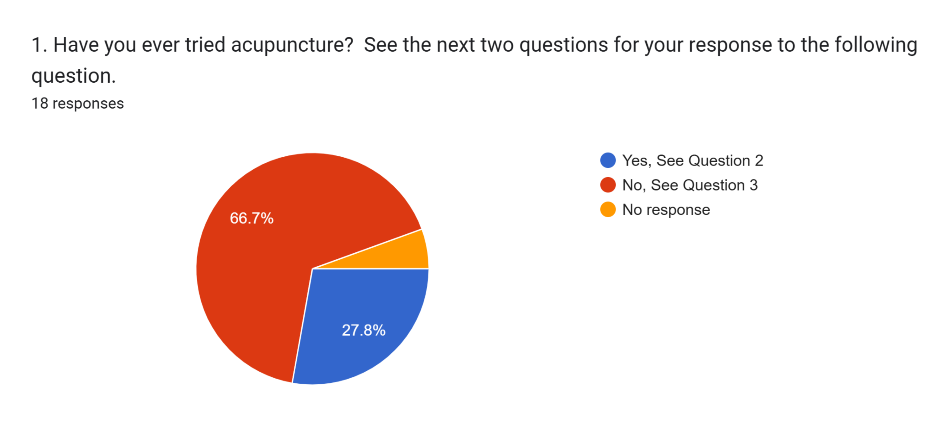
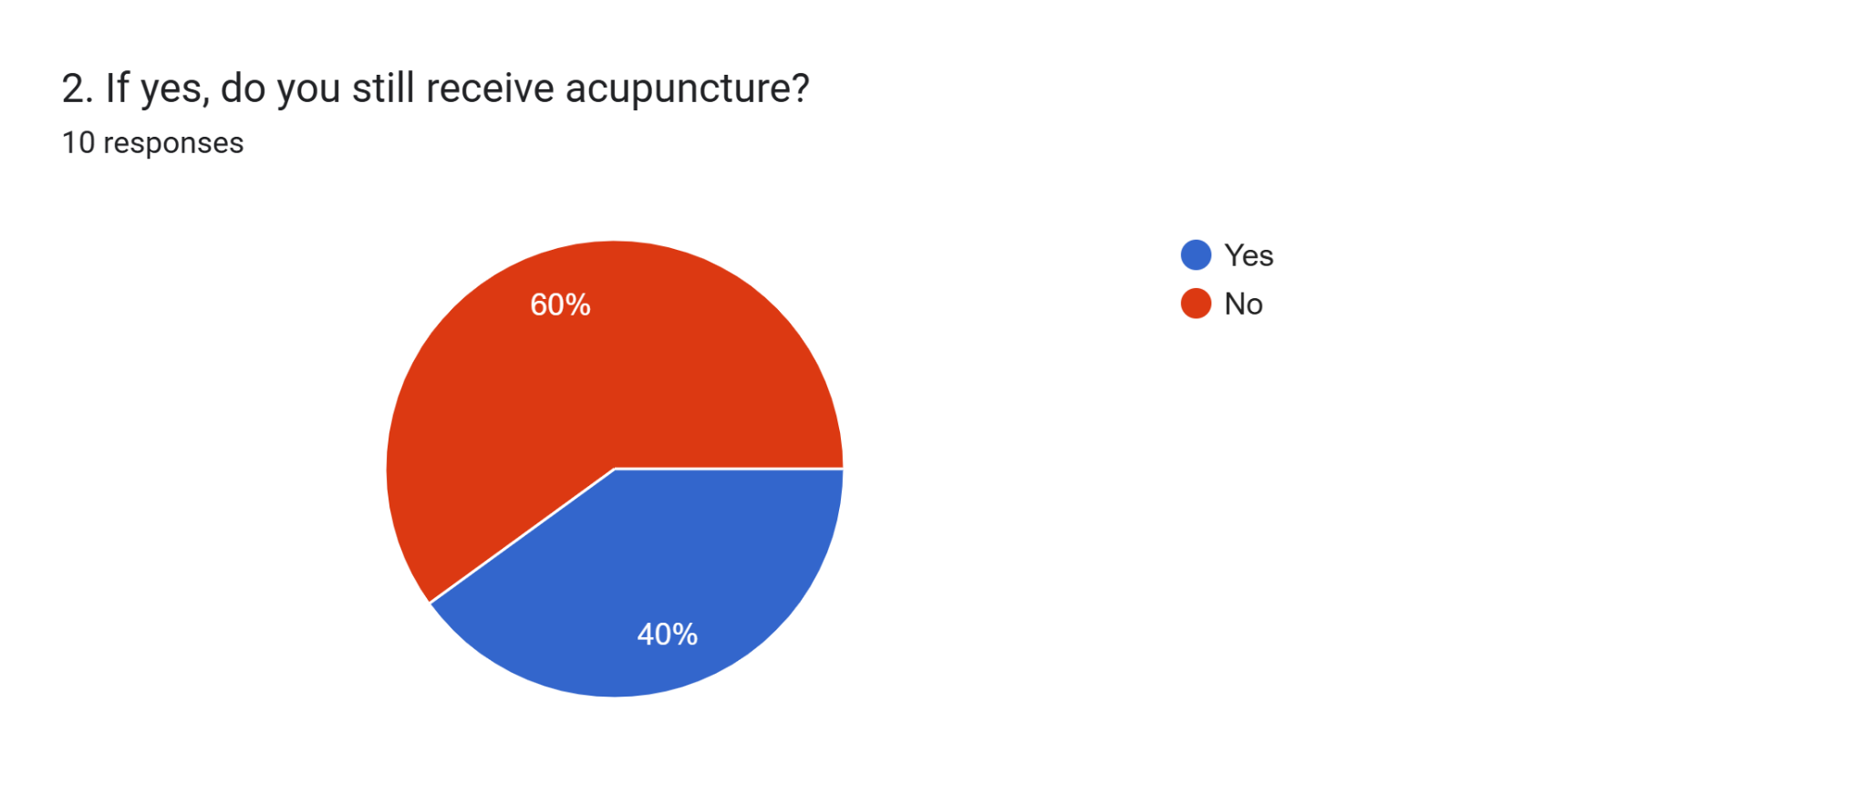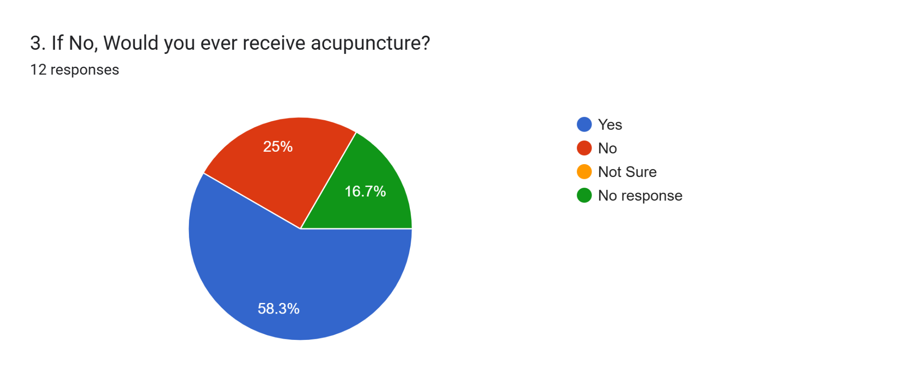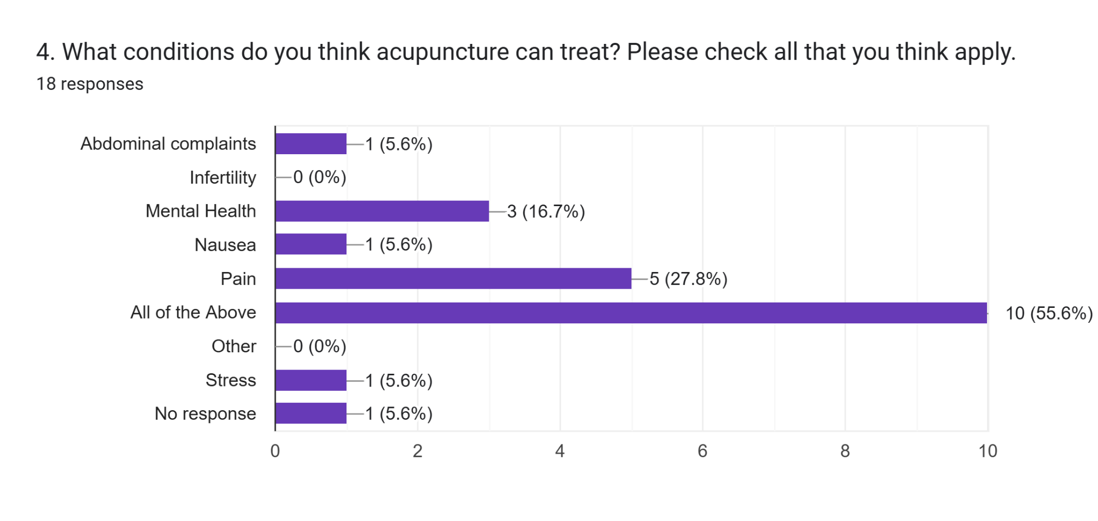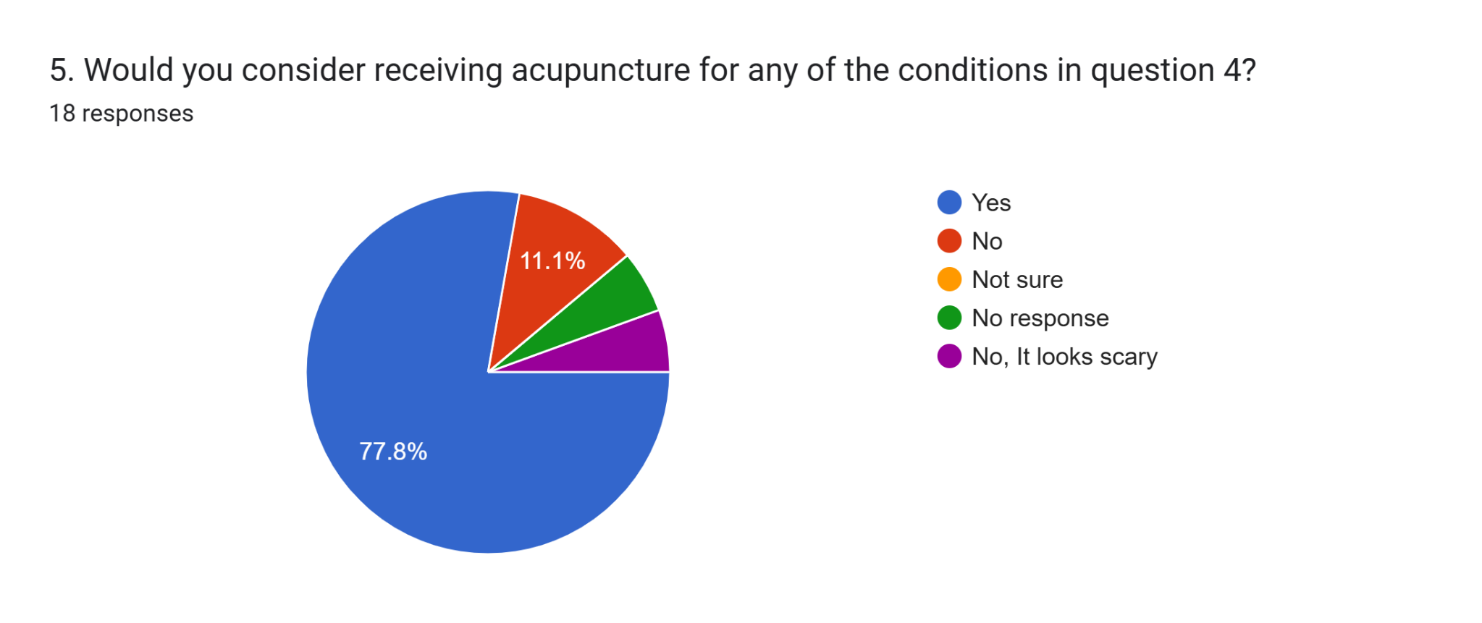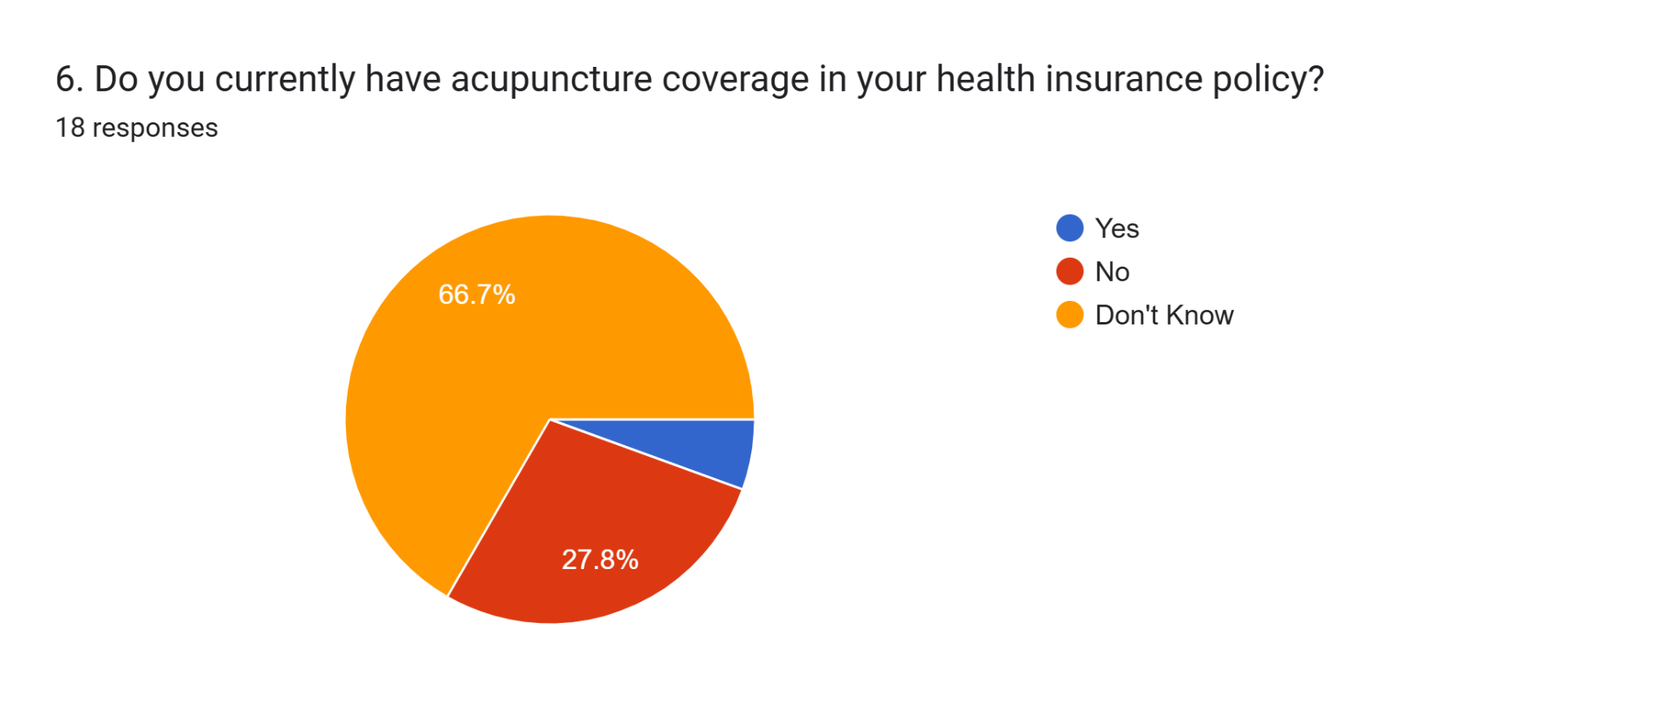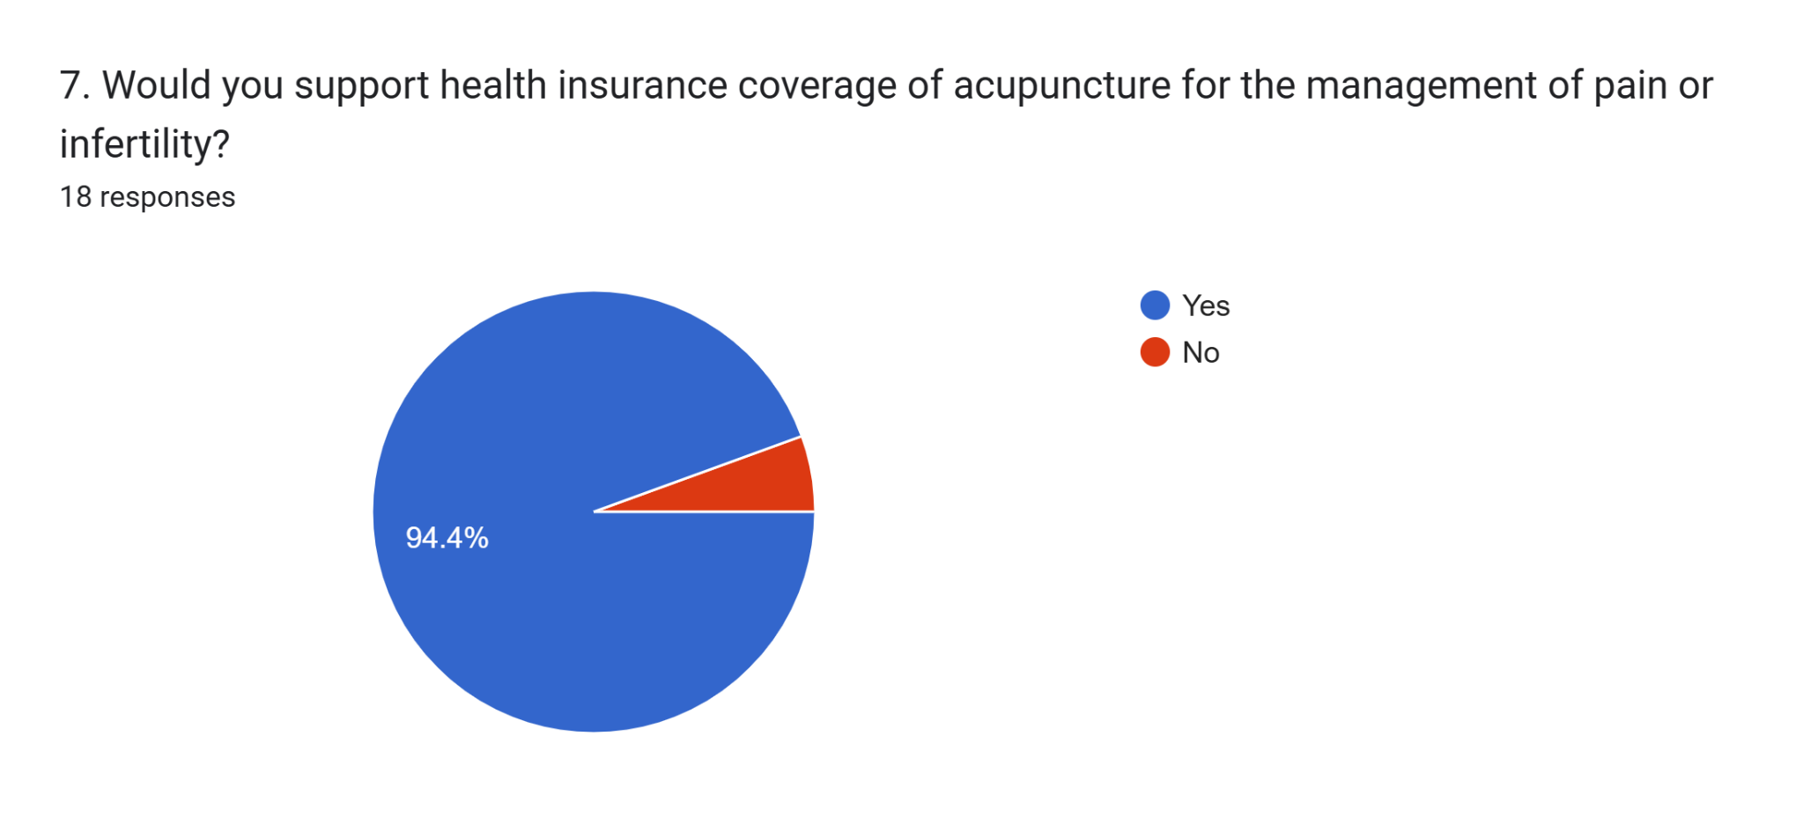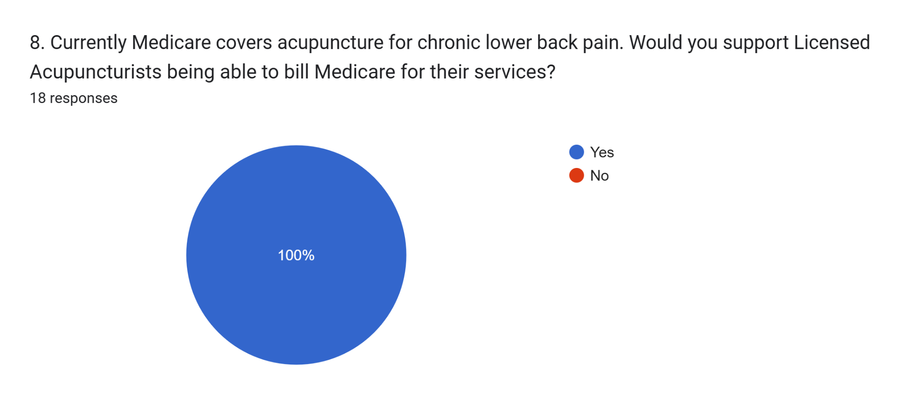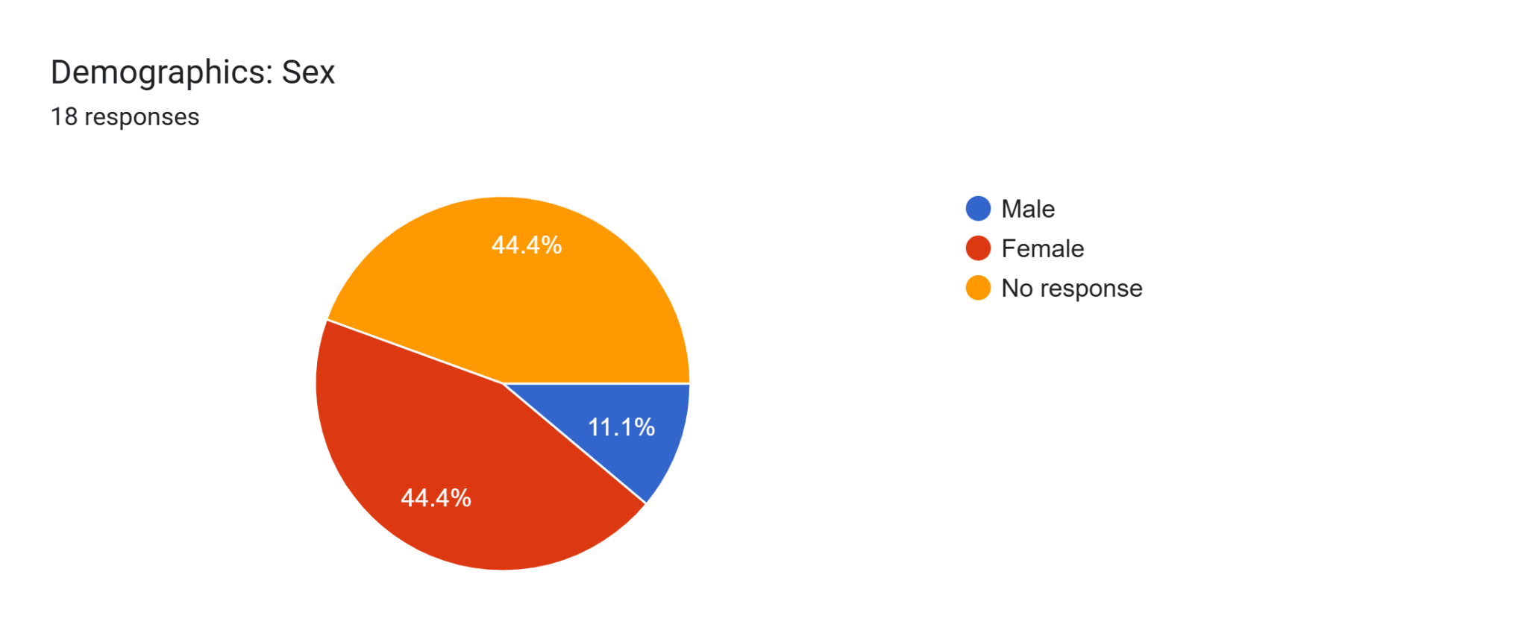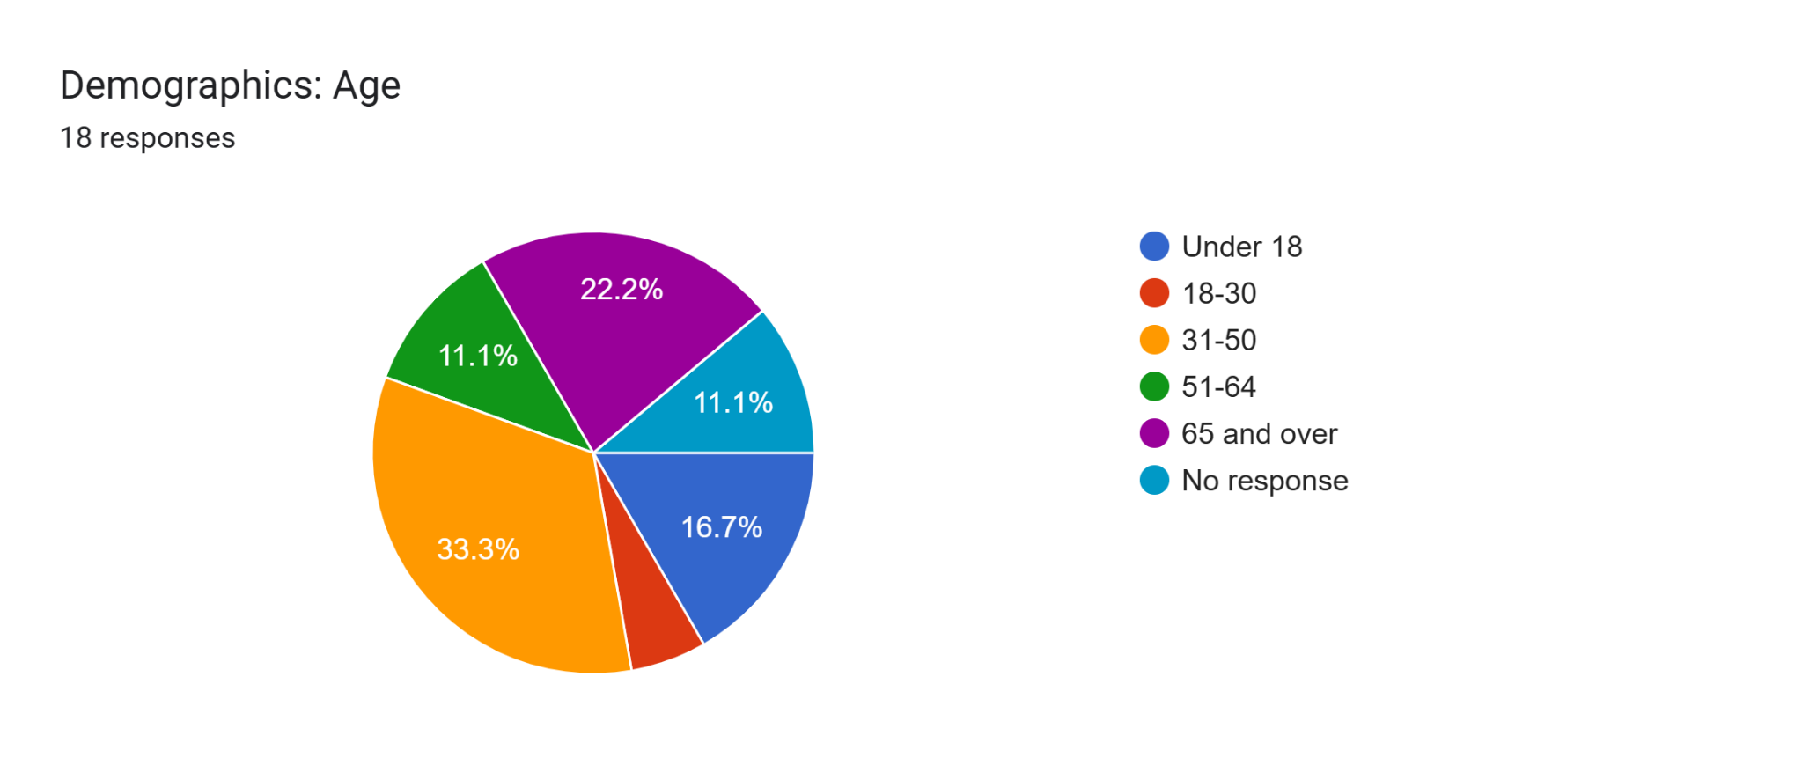
County of Residence
